YEAR 7 MATHEMATICS · 2026 YEARLY EXAM
Help Sheet
Keep this beside you while you do the practice exams. Try each question first, then use this sheet if you get stuck. No calculators – all methods here are by hand.
1. Number
Part A Q2–Q5, Q11 · Part B Q5, Q10
Topic | What you need to know | Example
Order of operations | Brackets first  then × and ÷ (working left to right)  then + and − (working left to right) | 5 + 2 × (7 − 3)  = 5 + 2 × 4  = 5 + 8  = 13
Ascending and descending | Ascending = smallest to largest (going UP the stairs)  Descending = largest to smallest (going DOWN) | Ascending: −3, 0, 2.5, 8  Descending: 8, 2.5, 0, −3
Place value of decimals | After the decimal point:  1st place = tenths  2nd place = hundredths  3rd place = thousandths  4th place = ten thousandths | In 4.2617:  2 is tenths, 6 is hundredths,  1 is thousandths, 7 is ten thousandths
Index notation | The index (power) tells you how many times to multiply the base by itself.  It does NOT mean base × index. | 2⁵ = 2 × 2 × 2 × 2 × 2 = 32  4³ = 4 × 4 × 4 = 64 (not 12!)
Negative numbers (integers) | Numbers left of zero are negative. The further left, the smaller.  Adding a positive → move right.  Subtracting a positive → move left. | −4 + 9 = 5  −2 − 6 = −8  −7 + 3 = −4  3 × (−2 + 7) = 3 × 5 = 15
Mental strategies | Look for pairs that make 10, 20, 50 …  × by hundreds: multiply, then add the zeros.  Round and adjust, or split the number. | 16 + 9 + 4 + 11 = 20 + 20 = 40  3 × 400 = 12 hundreds = 1200  18 × 4 = 20 × 4 − 2 × 4 = 72  23 × 6 = 120 + 18 = 138

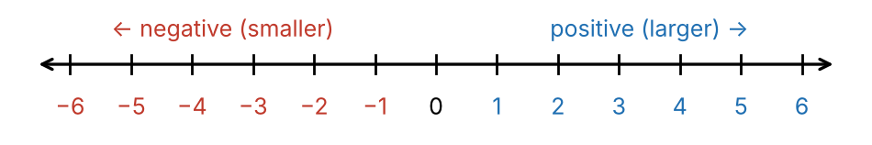

2. Fractions and decimals
Part B Q3, Q4, Q6
Topic | What you need to know | Example
Equivalent fractions | Multiply (or divide) the numerator AND the denominator by the same number.  If the top and bottom are not multiplied by the same number, the fractions are NOT equal. | 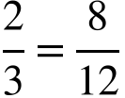 True (× 4)  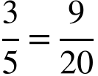 False  (3 × 3 = 9 but 5 × 4 = 20)
Multiplying fractions | Multiply the tops, multiply the bottoms, then simplify. | 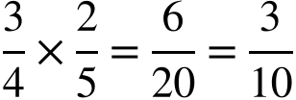
Multiplying a decimal | Ignore the decimal point, multiply, then put back the same number of decimal places. | 0.7 × 4: 7 × 4 = 28 → 2.8  0.9 × 3: 9 × 3 = 27 → 2.7
Improper fraction → mixed number | Divide the numerator by the denominator. The answer is the whole number; the remainder goes over the denominator. | 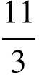 → 11 ÷ 3 = 3 r 2  so 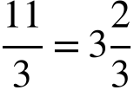
Mixed number → improper fraction | Whole number × denominator, + numerator. Keep the same denominator. | 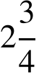 → 2 × 4 + 3 = 11  so 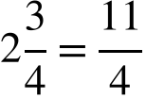

3. Algebra
Part A Q7 · Part B Q7, Q8, Q9, Q11
Topic | What you need to know | Example
Variable (pronumeral) | A letter that stands for a number we don’t know yet. | In 3n + 2, the letter n is the variable.
Writing expressions | more than, sum, increased by → +  less than, difference, decreased by → −  times, product, double → ×  divided by, quotient, half → ÷  No equals sign in an expression. | ‘4 more than a number’ → x + 4  ‘4 less than a number’ → x − 4  ‘the product of 3 and a number’ → 3x  ‘half a number’ →
Substitution | Replace each letter with its number, then follow the order of operations.  Letters next to each other are multiplied: ab means a × b. | If a = 3 and b = 5:  2a + b = 2 × 3 + 5 = 11  ab − 1 = 3 × 5 − 1 = 14
Collecting like terms | Like terms have exactly the same letters. Add or subtract the numbers in front.  Numbers on their own stay separate. | 3y + 5y = 8y  4ab + ab = 5ab (ab means 1ab)  6p + 3 − 2p = 4p + 3
Multiplying terms | Multiply the numbers, then write the letters. | 4 × 5t = 20t  2 × 3y = 6y
Solving one-step equations | Do the inverse (opposite) operation to both sides:  + ↔ − × ↔ ÷  Check by substituting your answer back in. | a + 5 = 12 → a = 12 − 5 = 7  b − 4 = 10 → b = 10 + 4 = 14  3c = 21 → c = 21 ÷ 3 = 7  = 9 → d = 9 × 2 = 18
Solving two-step equations | Undo + or − first, then undo × or ÷.  If the whole top of a fraction is divided, multiply both sides first. | 4a + 3 = 23  −3: 4a = 20  ÷4: a = 5  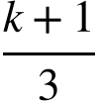 = 5  ×3: k + 1 = 15  −1: k = 14

4. Angles and shapes
Part A Q8–Q10, Q14, Q15 · Part B Q1, Q2
Topic | What you need to know | Example
Angle sum of a triangle | The three angles inside a triangle add to 180°.  Missing angle = 180° − (the other two).  Write the reason: ‘angle sum of a triangle is 180°’. | Angles 65°, 40° and x:  x = 180° − 65° − 40°  x = 75°
Types of triangles | Isosceles: 2 equal sides and 2 equal angles (opposite the equal sides).  Equilateral: 3 equal sides, all angles 60°.  Scalene: no equal sides. | Isosceles with equal angles of 50°:  third angle = 180° − 50° − 50° = 80°
Exterior angle of a triangle | Extend one side. The exterior angle = the sum of the two opposite interior angles.  (Or: 180° − the interior angle next to it, because angles on a straight line add to 180°.) | Opposite interior angles 45° and 70°:  exterior angle = 45° + 70° = 115°
Perimeter | Perimeter is the total distance around the OUTSIDE of a shape. Add all the side lengths.  (Area is the space inside – don’t mix them up.) | Rectangle 7 cm by 2 cm:  P = 7 + 2 + 7 + 2 = 18 cm

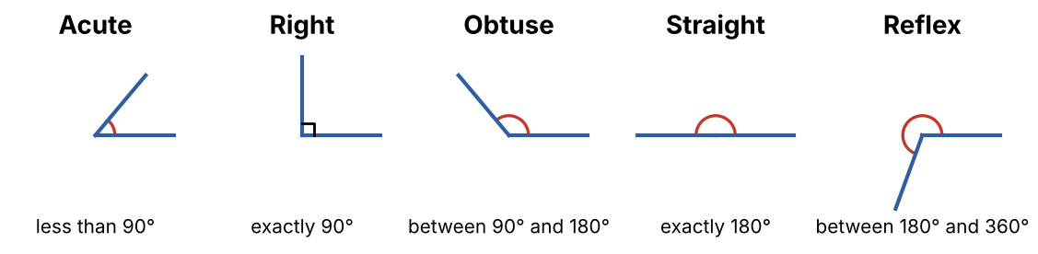
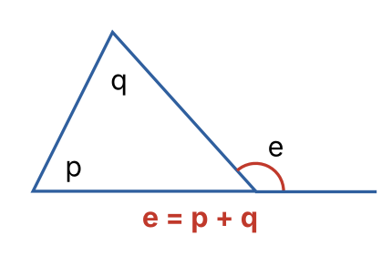 | Angles on parallel lines  Corresponding angles (F shape) are equal.  Alternate angles (Z shape) are equal.  Co-interior angles (C shape) add to 180° (supplementary).  Supplementary = add to 180°. Complementary = add to 90°.
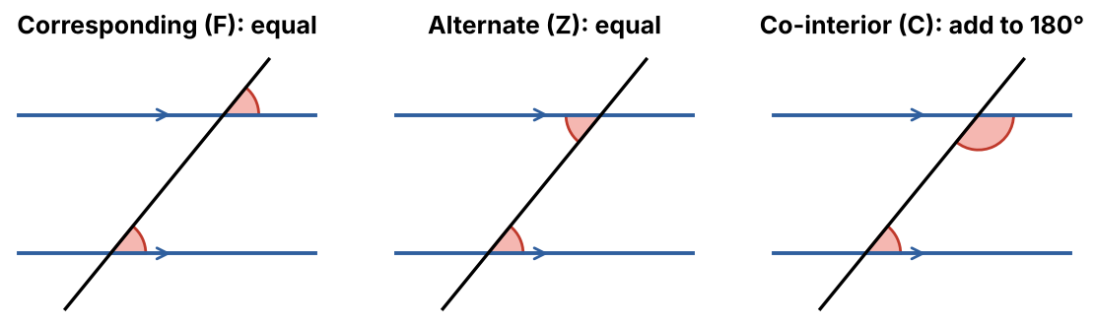

5. Statistics (data)
Part A Q1, Q2 · Part C Q12, Q13, Q14
Topic | What you need to know | Example
Mean | Add all the values, then divide by how many values there are. | 5, 8, 3, 8, 6  Mean = 30 ÷ 5 = 6
Median | Put the values in order. The median is the middle value.  If there are two middle values, add them and halve. | In order: 3, 5, 6, 8, 8 → median = 6  2, 4, 7, 9 → (4 + 7) ÷ 2 = 5.5
Mode | The value that occurs most often. (MOde = MOst) | 5, 8, 3, 8, 6 → mode = 8
Range | Highest value − lowest value. | 5, 8, 3, 8, 6 → 8 − 3 = 5
Adding a new value | Work everything out again with the new value included.  New mean = (old total + new value) ÷ (new number of values).  Re-order the data for the new median. | Add 12 to 5, 8, 3, 8, 6:  new mean = (30 + 12) ÷ 6 = 7  new median: 3, 5, 6, 8, 8, 12 → (6 + 8) ÷ 2 = 7
Outlier | A value that is much higher or much lower than the rest of the data. | 2, 3, 3, 4, 3, 15 → outlier is 15

Constructing a dot plot  1. Rule a horizontal number line.  2. Mark every value from the lowest to the highest, evenly spaced – even ones with no dots.  3. Put one dot above the value for each piece of data. Keep dots evenly stacked.  4. Label the axis and give it a title.  Total = count all the dots.  ‘Less than 3’ means 0, 1 and 2 – NOT 3. | 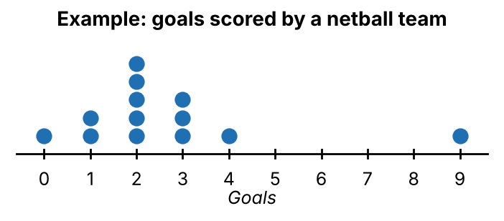

Column graphs | Read across from the top of each bar to the scale.  Total = add the height of every bar.  A day has 24 hours, so a fraction of a day = hours ÷ 24. Simplify! | 8 hours of a day:  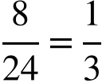  3 hours of a day: 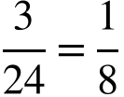

6. Probability
Part A Q12, Q13 · Part C Q15
Topic | What you need to know | Example
Sample space | A list of every possible outcome, each written once, inside curly brackets { }. | Die: {1, 2, 3, 4, 5, 6}  Coin: {heads, tails}  Spinner: {red, blue, green}
P(E) | P(E) means ‘the probability of event E happening’.  P(E) = number of favourable outcomes ÷ total number of outcomes.  On a spinner with equal sections, count the sections. | Spinner with 5 equal sections, 2 are red:  P(red) =  Die: P(even) = 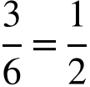
Probability scale | Probabilities are between 0 and 1.  0 = impossible  = even chance  1 = certain | P(rolling a 7 on a die) = 0  P(rolling less than 7) = 1
Complement | The complement of E is ‘E does NOT happen’ – all the other outcomes.  P(not E) = 1 − P(E). | P(red) =  Complement: not red  P(not red) = 1 − 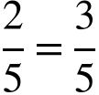

Exam tips

• About one minute per mark. If you are stuck, move on and come back.
• Multiple choice: read all four options, cross out the ones that are wrong, then circle ONE letter.
• Show your working – marks are given for the method, not just the answer.
• Check equations by substituting your answer back in. Check probabilities are between 0 and 1.
• Bring a black pen, pencil, ruler and eraser. A calculator is NOT allowed.

